Project Title :

CampusDrive – Smart Placement & Training Management System

Objective :
The main aim of this project is to manage the college placement process easily. It helps the placement cell to store student records and filter them according to company criteria like CGPA or backlogs. It also helps in scheduling interviews and tracking student progress in training.
Introduction :
In our colleges, managing placement data in Excel sheets is very difficult and confusing. "CampusDrive" is a software built using data structures to automate this. It stores student data and allows the placement officer to search for eligible students instantly. This system makes the recruitment process faster and more organized during the placement season.
Technical Stack (Technologies used) :
- Language : C Language.
- Data Structures : Hash Maps, Sorting Algorithms (Quick Sort), Queues, and Binary search tree.
- Tools : VS Code.
- Storage : File Handling (.txt or .csv files) to save student and company records.
Methodology :
- Student Database : We use Binary Search Trees to store student records indexed by their Roll Number for fast searching.
- Eligibility Filtering : Sorting Algorithms are used to rank students based on their CGPA for specific company requirements.
- Interview Scheduling : Queues (First In First Out) are used to manage the sequence of students waiting for their interview rounds.
- Department Sorting : Hash Maps are used to quickly categorize students based on their branch (CSE, ECE, etc.)
Architecture :
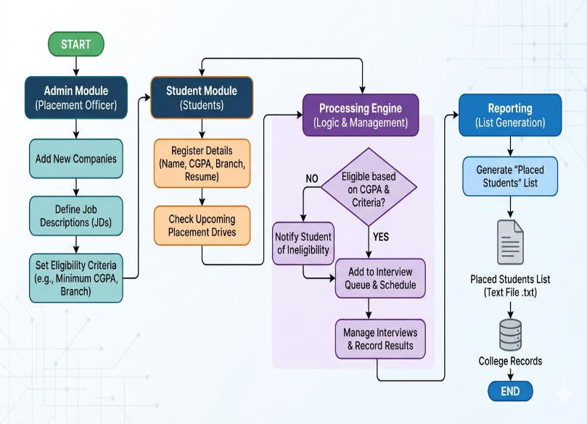
Conclusion :
This project proves that data structures are not just for exams but very useful in college management. By using BST and Queues, we reduce the manual work of the placement cell and make the data more secure and easy to access compared to old paper methods.
Future Enhancement :
- Adding an self balanced tree for better balancing of student records when the data is very large.
- Implementing Graphs to show placement trends and statistics of previous years.
- Creating a Web Interface so students can login from their mobile phones.

SUBMITTED BY :
U. VENKATA PAVANI
ROLL NO : 25P61A05AB

